NEIGHBORHOOD VOLUNTEER TASK BOARD
@CREATIVITY THINK (9483175986/7019689991)

ABSTRACT:
Neighborhood Volunteer Task Board is a dynamic web application designed to connect community members who need help with volunteers willing to serve. The platform enables users to post tasks such as grocery assistance, teaching support, or small errands, while volunteers can browse, accept, and complete tasks with proof submission. Equipped with an impact dashboard, the system helps measure community contribution in terms of hours served, people helped, and participation trends. Built using Django REST framework and React, the system ensures seamless user interaction and efficient task coordination for RWAs, NGOs, and college clubs..

INTRODUCTION OF THE PROJECT:
Community support often lacks structure, transparency, and coordination, making it difficult to match help requests with available volunteers. Neighborhood Volunteer Task Board addresses this gap by providing a centralized digital platform where users can request or offer help, track task status, upload completion proof, and view impact analytics. For organizations, the platform serves as a managed volunteer system with tools to verify tasks, validate submissions, control abuse, and evaluate community service results..

PROJECT OBJECTIVES:

• Build a centralized platform for community help requests and volunteer coordination
• Provide an easy interface for users to post or accept tasks
• Enable volunteers to update progress and submit completion proof
• Maintain transparency through task validation and monitoring
• Offer an impact analytics dashboard for hours served and beneficiaries
• Support community groups, NGOs, and colleges in managing volunteers
• Prevent misuse by validating tasks and flagging spam
• Enable easy data export for CSR, NGO reporting, or club documentation

PROBLEM OF THE STATEMENT:
Communities face challenges in matching people who need help with volunteers who are ready to assist. There is no streamlined method to track progress, verify task completion, measure community impact, or prevent fraudulent tasks. This results in poor coordination and lack of accountability. Neighborhood Volunteer Task Board solves these issues by offering a structured system for task posting, volunteer assignment, proof submission, validation, and impact reporting..

MOTIVATION OF THE PROJECT:
• To empower neighborhoods with an organized volunteer-help system
• To promote social responsibility among youth and communities
• To simplify how people request everyday support
• To enable NGOs and RWAs to track volunteer impact efficiently
• To prevent misuse of volunteer platforms through admin validation
• To make volunteer work measurable with analytics
• To streamline CSR and social reports through exports

BLOCK DAIGRAM OF PROJECT:

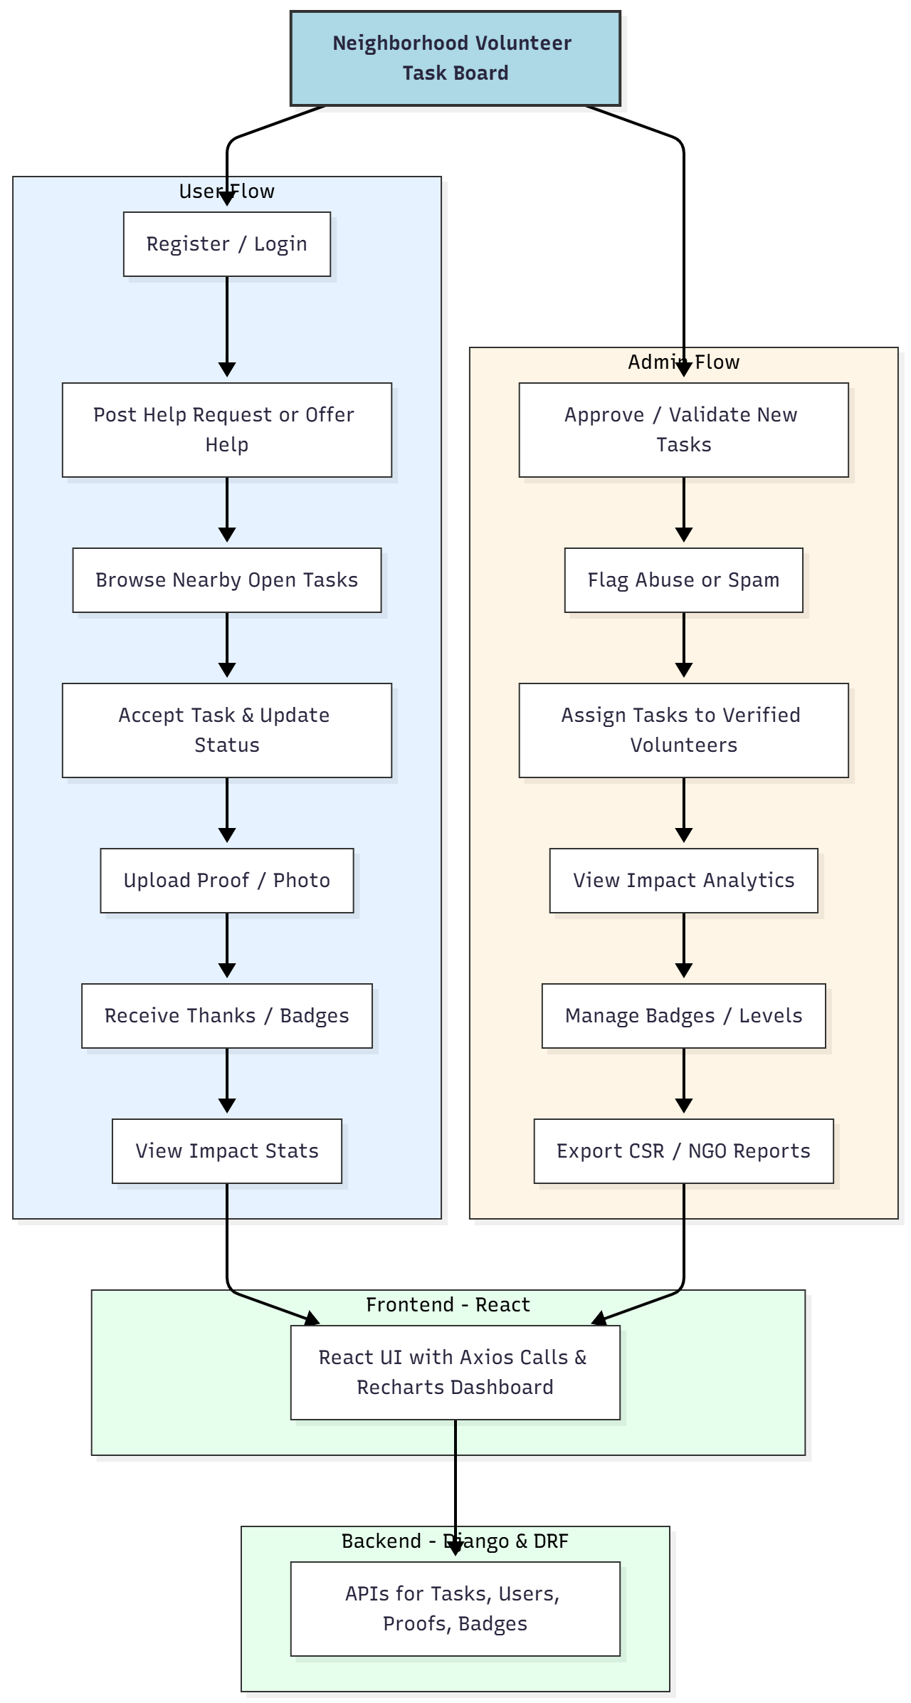

WORKING OF THE PROJECT:
Users create accounts and can either post tasks where they need assistance or offer help to others. Volunteers browse a list of available tasks filtered by proximity and interest. Once a task is accepted, the volunteer updates progress and uploads proof such as photos or documents. Admins validate each task, prevent abuse, and ensure only genuine activities are approved. Badges and levels motivate volunteers to contribute more. An impact dashboard displays community service metrics, helping RWAs, NGOs, and colleges track contributions and generate CSR-ready reports..

SOFTWARE REQUIREMENT:
- Backend:
  - Python 3.x
  - Django
  - Django REST Framework
  - SQLite/PostgreSQL
- Frontend:
  - Node.js and npm
  - React.js
  - Axios
- Development Tools:
  - Visual Studio Code
  - Postman (for testing APIs)
  - Git/GitHub (for version control)
- Server/Deployment (Optional):
  - Gunicorn, Nginx, or Heroku/AWS for hosting

ADVANTAGES OF THE PROJECT:

• Streamlined community help platform
• Reduces communication gaps between volunteers and people in need
• Proof-based system ensures authenticity of completed tasks
• Badges and levels encourage active volunteering
• Fully measurable impact through analytics dashboard
• Helps NGOs and RWAs in reporting and documentation
• Prevents spam and misuse through admin verification
• Enhances community bonding and responsibility

APPLICATIONS OF THE PROJECT:
• Residential Welfare Associations (RWAs)
• NGOs running volunteer programs
• College clubs and youth organizations
• Community service groups
• CSR volunteer tracking

REFERENCES:

- Django REST Framework Documentation — Django Software Foundation. Django Documentation. Available: https://docs.djangoproject.com/
- Django REST Framework. DRF Documentation. Available: https://www.django-rest-framework.org/
- React. React Official Documentation. Available: https://reactjs.org/docs/getting-started.html
- Redux. Redux Documentation. Available: https://redux.js.org/introduction/getting-started
- PostgreSQL Global Development Group. PostgreSQL Documentation. Available: https://www.postgresql.org/docs/
- MySQL. MySQL Reference Manual. Available: https://dev.mysql.com/doc/
- Git. Git Documentation. Available: https://git-scm.com/doc
- Node.js. Node.js Documentation. Available: https://nodejs.org/en/docs/
- Axios. Axios Documentation. Available: https://axios-http.com/docs/intro
- Socket.io Documentation – https://socket.io/docs/

